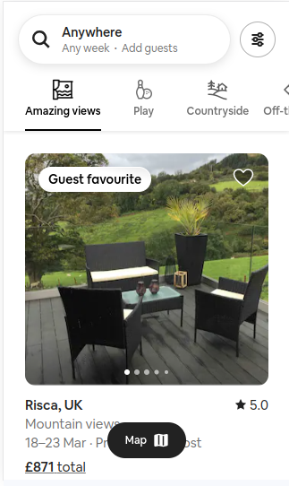
Search bar
filters button

Category, repeatable

Listing, inc:
Tagline
Favourite?
Description
Rating

Map icon (scrolls)

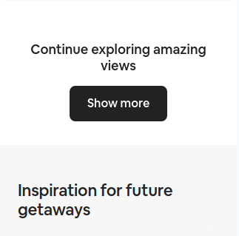

Show more section
Show more button

Suggestions
scrollable menu
alphabetic suggestion
by city
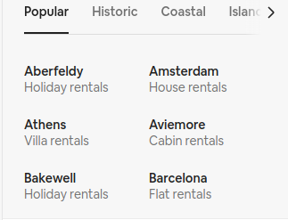

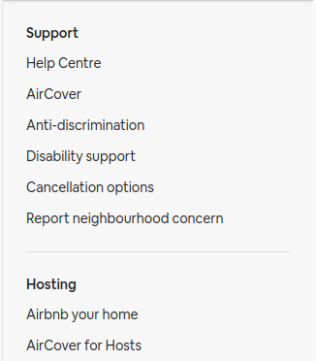

Help and misc

Title
Links

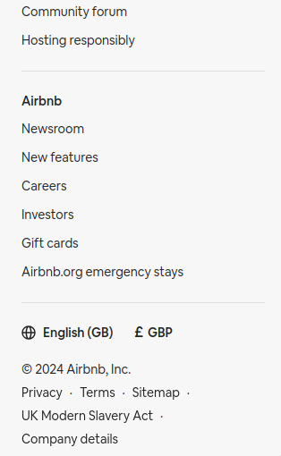

Legal details



Menu (scrolls)

